Lab 5 Report

By,

(Group4)

Dayanand Saraswathi

Sirish Madanapally

Manohar Reddy

Ravisha Goud

Below are the screen shots of the wordcount program in scala. We used the cloudera virtual machine.

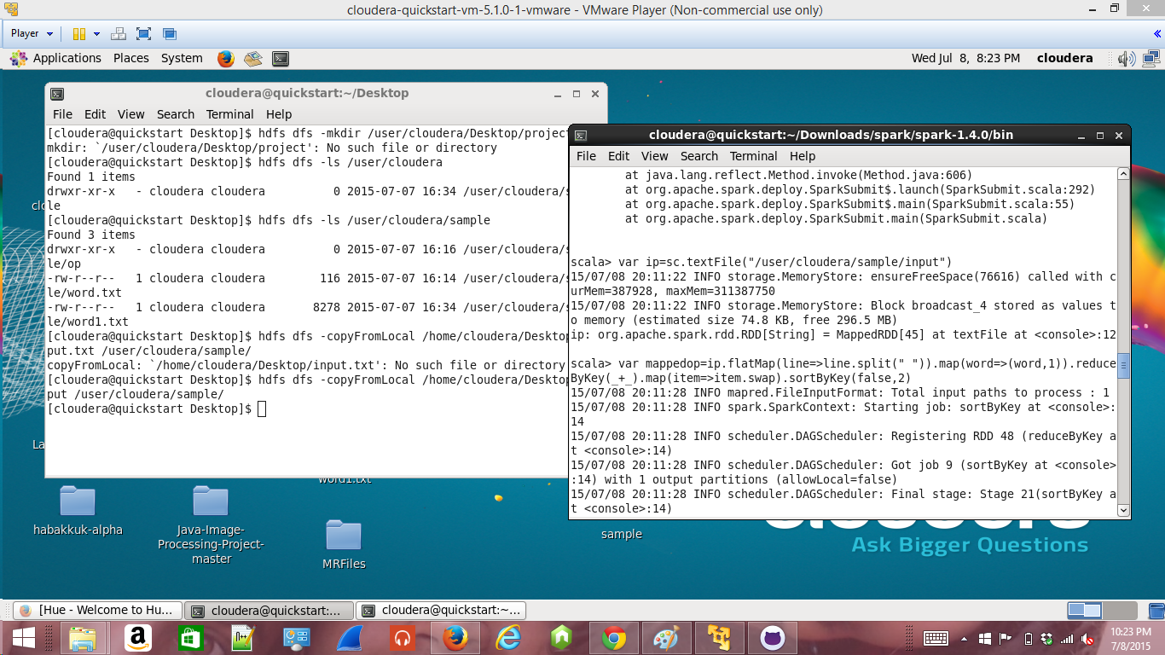

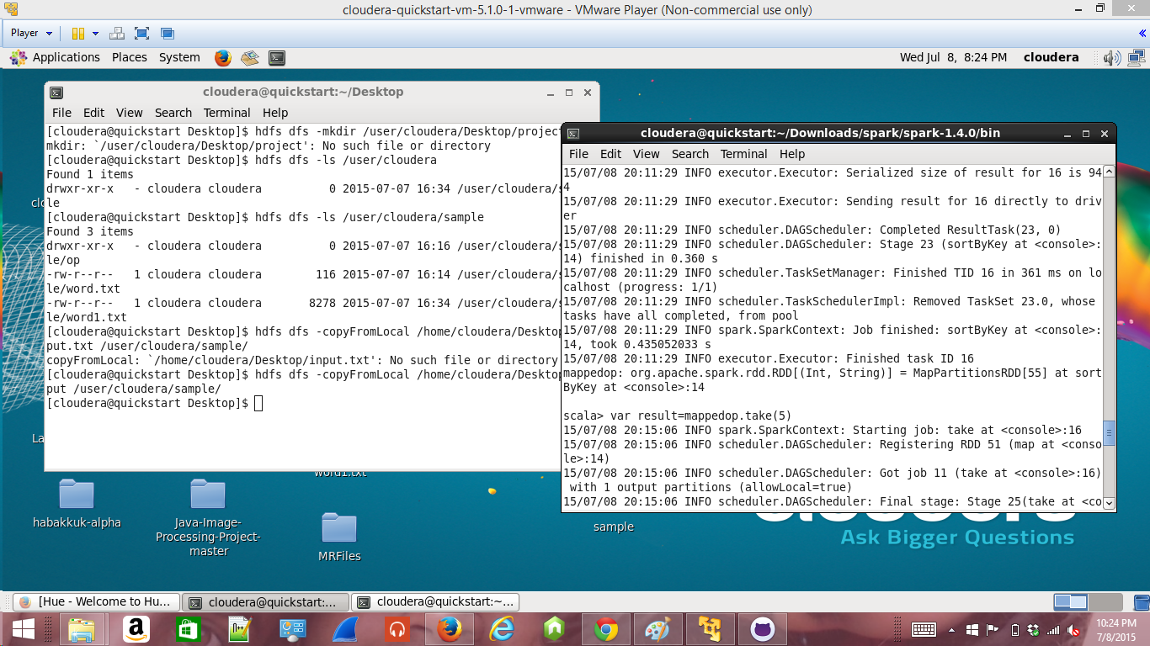

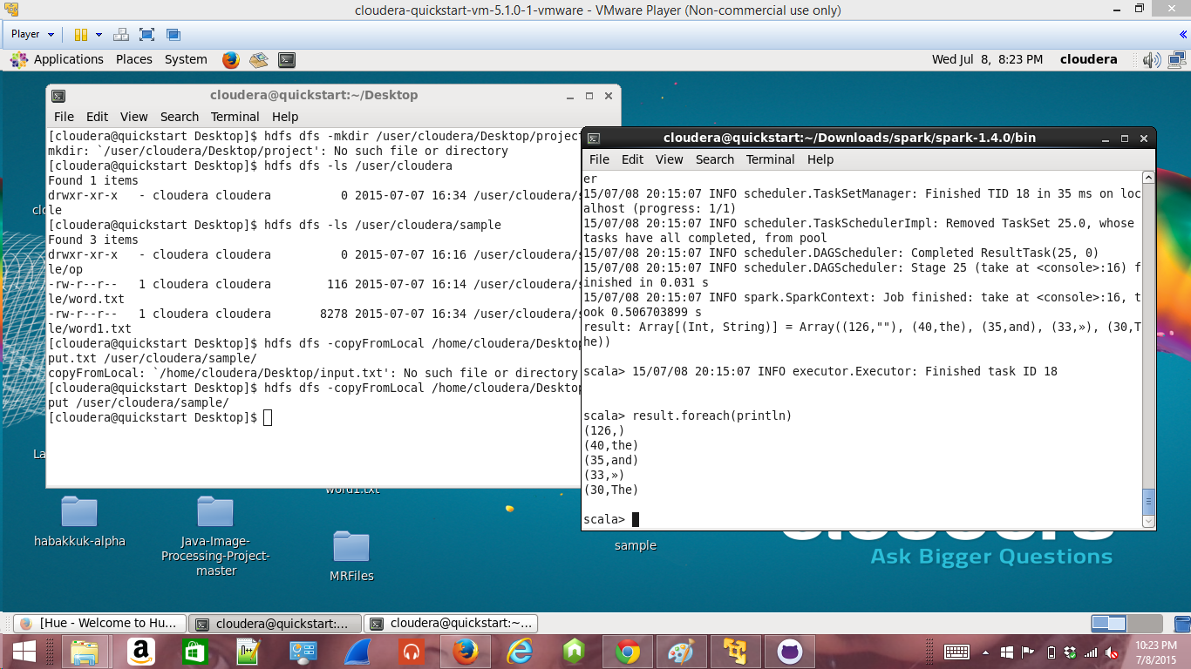

The server was down when we tried to execute the scala script. So we executed in the cloudera vm using Vm palyer on local machine.